Healthy Bytes Initiative Article
April 2021 Split Peas

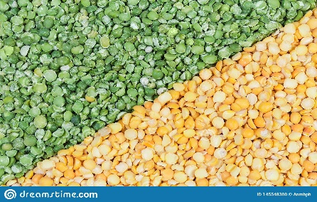
Enjoying Split Peas
By Stephanie Polizzi, MPH, RDN, DipACLM

Split peas belong to the family of legumes alongside beans and lentils. Like their family members, split peas are a good source of protein and fiber. They contain nutrients and compounds that support health and prevent chronic diseases like diabetes, heart disease, high blood pressure, inflammation, osteoporosis and many types of cancer.
Split peas are dried, round peas that split naturally, making them faster for cooking. Green and yellow varieties are most common. Green split peas have a higher content of chlorophyll which also gives them a stronger flavor than the yellow variety. Like all legumes, split peas are a good source of protein. The 8 grams in 1/2 cup split peas is equivalent to that found in 1 ounce of meat, 1 egg or an 8 oz glass of milk. The advantage to plant sources of protein like split peas is that they contain no fat or cholesterol.
Split peas are rich in B vitamins like thiamin (B1), important for energy metabolism and growth, pantothenic acid (B5) for break down fats and folate (B9) for protein metabolism and formation of DNA. Molybdenum is a trace mineral important for metabolizing drugs and chemical toxins like sulfite preservatives. Other minerals include phosphorus for healthy bones and teeth, magnesium for muscle and nerve function, including the heart muscle, copper for iron metabolism and immune function, and manganese for cholesterol, glucose and carbohydrate metabolism.
In addition, plant compounds like phytates and isoflavones work to prevent disease. Phytates have antioxidant and anti-cancer activity and may protect against kidney stones. Isoflavones are a plant estrogen that can inhibit cancer cell growth and malignancy. These compounds are also helpful for maintaining healthy blood vessels, lowering cholesterol, inhibiting bone loss and improving sleep quality.
Like all legumes, split peas are a good source of fiber, especially soluble fiber. Soluble fiber has been shown to lower cholesterol by binding and eliminating it from the body, reducing risk of heart disease and other vascular issues related to blood circulation. It can also help to modulate blood sugar levels to prevent diabetes and help with diabetes control, and it contributes to feelings of fullness that aids in weight management.
Split peas can be found packaged or in bulk bins. They will store for several months in an airtight container in a cool, dark place, or in the refrigerator. Unlike their dried bean cousins, they do not require soaking before cooking. Use 3 cups water or broth to every 1 cup split peas. Bring to boil, then cover and simmer until soft, 30–40 minutes. Split peas will absorb water so check them occasionally and add water as necessary to prevent scorching.
Split peas are most often associated with soup, but you can also try using them to make dahl or pilaf. Pureed cooked split peas can be used for making sauces for casseroles or gravies for side dishes. Just add spices. Or use pureed split peas for making hummus, vegetable dips or sandwich spreads. Crunchy split peas can be used as a healthy afterschool snack or topping for desserts. However you choose to enjoy split peas, you can be assured they are a great addition to a healthy, disease-fighting diet.

