Healthy Bytes Article
Jul 2018 Blueberries

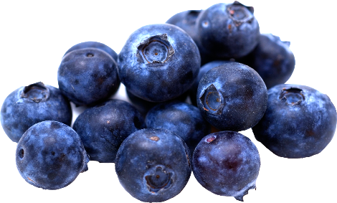
Blueberries: A Handful of Health
By Stephanie Polizzi, MPH, RDN

Blueberries are a sweet summer treat that are low in calories
but pack a powerful punch in the fight against chronic disease.
Their arsenal of nutrients includes a variety of antioxidants that
protect cells and fight free radicals. Blueberries are believed to
contain the highest antioxidant capacity of all commonly-consumed fruits and vegetables.

Antioxidants protect against DNA damage which occurs naturally as part of aging, digesting, exercise and energy metabolism. Studies have shown that small amounts of daily berries can not only protect against free radical damage, but can also aid in boosting immune function, lowering cholesterol and blood pressure and fighting urinary tract infections.

Blueberries are associated with reduced risk of heart disease and stroke because they have been shown to improve artery function. The polyphenol antioxidants prevent LDL cholesterol from oxidizing or “going bad,” giving HDL cholesterol time to clear it from the arteries.

Some diabetics avoid fruit due to the high sugar content. Despite their sugar content, studies show that blueberries improve insulin action and reduce resistance, lowering blood sugar levels. When this effect is combined with the improved artery function, blueberries are a perfect summer fruit for diabetics and those diagnosed with pre-diabetes.

Select blueberries that are firm, plump and completely blue, with a silvery sheen and no tinge of red. Bring them home and store, unwashed, in the refrigerator or freezer until ready to use. Refrigerated berries can last up to 10 days. To freeze berries, lay unwashed on a cookie sheet and freeze solid. Then move to storage containers. Before use, wash berries thoroughly. If purchasing frozen berries, be certain the berries are loose in the bag and not solid, which may indicate thawing and refreezing. Once frozen berries are thawed, they last 3-4 days in the refrigerator.

Picking your own blueberries can be fun for the whole family. Most blueberries are ripe from mid to late July through min August. Ripe berries should roll off the stem. If it doesn’t come off, it’s probably not ripe.

There are many ways to add blueberries to your summer meals. Sprinkle fresh berries into salads, cereal, pancake batter or on ice cream. Use frozen berries in smoothies and shakes, muffins or scones. Puree and freeze into popsicles or ice cream. Blueberries make great syrup, jam or preserves. You can also puree and pour into your dehydrator to make fruit leather which is great for packing on bike rides or hiking trails. If you’re staying put this summer, toss fresh berries into margaritas, mojitos or iced tea for a refreshing boost of berry benefits.

