
Healthy Bytes Initiative Article
December 2020 Walnuts

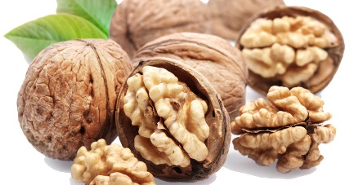
Wonderful Walnluts
By Stephanie Polizzi, MPH, RDN, DipACLM

Walnuts are a crunchy, delicious and healthy addition to your
daily diet. But did you know walnuts are good for your heart?
Like other tree nuts, walnuts are rich in vitamins, minerals,
healthy oils and fiber. Despite their high fat content, walnuts contain mainly healthy, unsaturated fats and have more omega 3 fat than any other plant food. Omega 3 fats help lower blood pressure and slow the development of plaque in the arteries. Walnuts do not contain cholesterol (only found in animal foods) but do contain a plant version of cholesterol, called phytosterols, which helps lower LDL cholesterol and triglycerides, reducing your risk for heart disease.

Walnuts contain folate, which lowers homocysteine, a compound associated with arterial disease. Other nutrients include niacin, B6, vitamin E (antioxidant), calcium, magnesium and potassium. These nutrients, along with the low sodium content of walnuts, work together to protect against bone loss, hypertension and insulin resistance. Several of the bioactive compounds in walnuts, like ellagic acid and polyphenols, are associated with lower risk of colon and prostate cancer.

Walnuts are also a good source of protein, which is made up of amino acids. One amino acid found in nuts is L-arginine, which helps the body to produce nitric oxide. Nitric oxide is a vasodilator, increasing the artery diameter so more blood can circulate, keeping artery walls smooth and flexible. This helps the body to deliver more oxygen and nutrients to cells and organs, which benefits multiple disease states.

Raw walnuts can be a great addition to any diet. Even though they are high in fat, they are not associated with increased risk of obesity. One ounce, about 14 walnut halves, is considered a daily serving. Be careful not to choose commercially-roasted and salted nuts since this adds fat and sodium, likely to counter the benefits. To get the most flavor from your walnuts, try toasting whole walnuts by heating in a dry skillet over medium heat, stirring constantly for 1-2 minutes until they are golden brown and start to smell delicious. It is recommended not to chop walnuts before toasting.

Because of the high oil content of walnuts, store them in the refrigerator if you plan to use them right away. Keep extra in your freezer in an air-tight container. Chop or grind right before you use them for the best flavor. If walnuts sit too long in an opened container, the oils can go rancid or spoil. Although still edible, the flavor is undesirable.

There are many ways to include walnuts into your meals. Toss them into salads, vegetable side dishes or oatmeal, or fold into meatloaf or burgers. You can use walnuts to create meat alternatives like taco meat or meat balls for tomato sauce. Use in cookies, muffins or bread for an added crunch. Puree in a high-speed blender to make walnut pesto for pasta, hummus for vegetables, or walnut butter for your morning toast. This holiday season, add walnuts to your mashed sweet potatoes or butternut squash. However you choose to use them, walnuts are a great, nutritious addition to a heart-healthy diet for the whole family.

