
Healthy Bytes Initiative Article
March 2020 Garlic

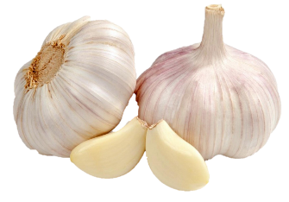
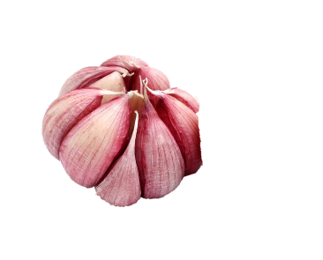
Health Benefits of Garlic
By Stephanie Polizzi, MPH, RDN

Garlic is an edible bulb from the lily family which
has been used for centuries as medicine by ancient
Sumerians and Egyptians. The Greeks fed Olympic
athletes garlic to increase stamina, and ancient Chinese used garlic to treat leprosy and infection. Garlic is an essential ingredient in the Mediterranean diet, known for its health benefits.

Garlic’s odor comes from sulfur compounds, including allicin, its principle active ingredient. This compound is also found in other members of the allium family, like onions, shallots, leeks and chives. Some studies show anti-microbial, anti-fungal and anti-viral effects of these foods.

Garlic may have potential health benefits to fight several of our most prevalent chronic diseases. It is a powerful anti-inflammatory food. Studies show garlic may help lower blood pressure and cholesterol and protect against formation of blood clots, particularly post-surgery. Some studies demonstrate garlic’s ability to regulate blood glucose.

Much of the research on garlic and other Sulphur-containing foods relates to cancer prevention. Like cruciferous vegetables (cabbage, broccoli, Brussels sprouts), garlic contains a large number of anti-cancer compounds. These foods have been shown to scavenge free radicals and slow the growth of cancer cells. Some studies demonstrate anti-tumor effects and increased rate of the breakdown of carcinogens in our body. Risk may be lowered for colon, stomach, lung, breast, brain and endometrial cancers as well as leukemia. Studies indicate benefit from garlic consumption may be temporary or sporadic, and should not be used in place of recommended medications.

Garlic supplements do not seem to have the same beneficial effects, and some have been shown to interfere with drug effects. Garlic, whether supplements or whole food, may contribute to excess bleeding in some individuals. Notify your doctor of garlic intake if you are planning any type of surgery or dental work.

Allicin is released when garlic is chopped or crushed. Cooking immediately can deactivate this reaction, so let garlic sit on the cutting board for 10 minutes before cooking. Chewing raw garlic, like using it on a salad, has potential benefit but also may have negative side effects like “garlic breath” or heartburn. Munching on raw mint leaves or apples can neutralize the sulfur compounds responsible for bad breath.

The best reason for using garlic is how it flavors our foods with zest. Look for plump bulbs with tight skin. Sprouted bulbs indicate garlic is aging. Store in cool, dark environment with ventilation. Press the side of your knife on clove to gently crush, making peels easy to remove. Add to soups, stews, potatoes, salads, hummus, even smoothies.

