Coos CAC Meeting
Meeting Date: April 02, 2026, 12:00 pm
Attendance
CAC Members
Katie Gonzalez, Jeanifer Imbruglia, Shannon Hunter, Coreen Lee, Holly Boardman, Celcionna Volluz (proxy SCREL), Corey Wampler, Matthew Lehman, Amber Nichole Majeski, Ariel Hicks, Anna Marie Slate, Stephanie Brouse, Trudy Simpson,

Staff and Guests.
Sam Baugh, Bevin Ankrom, Avery Horton, Brandy Hille, Ross Acker, Lisa Frischkorn, Doris Kiragu, Becky Yeager, Kelsey Statham, Kelcy Szetela, Danita Tracy Carter, Sarah Swanson

General Summary
- Referral Process Delays: Provider submission delays, not insurance, hinder timely patient care. Providers prioritize payment over timeliness.
- Authorization Timeframes: Insurance approvals can take days to two weeks, with complex cases generally facing longer delays due to provider issues.
- Survey Feedback Concerns: Members find surveys too long and intrusive, impacting response rates. Suggestions include shorter, more focused surveys.
- Cancer Screening Initiative: New funding provides $6,000 each for local clinics to enhance access to cancer screenings for Medicaid patients.
- HR1 Changes: New Medicaid eligibility rules begin in 2027, increasing renewal frequency and adding work requirements for adults, raising concerns about coverage loss.
- Community Engagement: Advanced Health promotes a 24/7 nurse triage line and hosts community events to support health equity and advocacy initiatives.

Action items

Sam Baugh
- Submit the referral process feedback and member concerns to the Advanced Health Board at the next meeting (17:15)
- Ensure CAC minutes and highlighted items are submitted to the Advanced Health Board regularly and posted online after website transition (01:15:45)
- Circulate community event flyers and meeting notices to council prior to next meeting (01:17:00)

Lisa Frischkorn
- Provide detailed information via email on prior authorization process and weekend pharmacy review timelines for urgent prescriptions (34:50)
- Send Nurse Triage Line informational flyer to Sam Baugh for distribution to council members (37:35)

Sarah Swanson
- Follow up with OHSU clinical trial contact and provide updates on local recruitment for cancer screening studies for Medicaid/Medicare population to Sam Baugh (44:00)

Bevin Ankrum (OHA)
- Continue providing detailed timely updates on HR1 implementation, exemptions, and eligibility rules to the community and partners (01:14:00)

All members
- Encourage outreach and education about upcoming eligibility changes, renewal requirements, and assistance resources to community members

Notes

Referral Process Challenges and Solutions
- The referral process bottlenecks largely stem from provider delays rather than insurance approval, creating significant barriers for members needing timely care.
- Referral delays caused by providers not meeting timely submission standards create gaps where referrals sit unprocessed despite claims of submission, as explained by Sam Baugh and highlighted by Jennifer’s case of a delayed neurology referral (07:55)
  - Providers lack mandated time frames to respond or submit referrals unlike coordinated care organizations
  - The main driver for providers submitting referrals is to ensure payment, not necessarily patient care timeliness
  - Provider competition and limited availability contribute to delays and competing priorities
  - Sam plans to raise this issue at the Advanced Health Board meeting to seek awareness and possible solutions
- Insurance turnaround times for prior authorization vary but generally range from days to two weeks as shared through personal experiences by Sam and others (10:40)
  - Some authorizations, such as MRIs, can be approved quickly if documentation is complete
  - However, referrals involving specialists or complex cases often face longer delays due to provider submission issues
- Customer service and care coordinators serve as critical support channels for members facing referral or authorization issues (09:27)
  - Members are encouraged to contact customer service or their care coordinator for assistance
  - Persistent follow-up (“pleasantly persistent”) helps overcome system gaps though it remains an inefficient burden on members
  - Complaint processes exist and should be used when no other remedy resolves issues, as Lisa Frischkorn reminded (18:13)
- Medication prior authorization challenges add another layer of complexity and cost risk for members as illustrated by a pediatric seizure medication case (29:37)
  - Prior authorization can take multiple days, sometimes over weekends, delaying critical medication access
  - Members may pay out-of-pocket initially but can seek reimbursement later
  - Pharmacy teams can expedite reviews if urgent, but processes remain opaque and stressful for families

Member Experience and Survey Feedback
- Members find current surveys overly long, intrusive, and poorly timed, which negatively impacts response rates and data quality.
- Members perceive surveys like the CAHPS as too long and intrusive, especially with repeated or highly personal questions (19:40)
  - Many skip sensitive questions such as sexual orientation due to discomfort
  - The survey’s six-month focus period excludes relevant experiences outside that window, causing confusion and incomplete responses
  - Suggestions include condensing surveys to fewer key questions to improve completion rates and relevance
- Despite confidentiality assurances, members question how non-response is tracked and addressed (20:32)
  - Members receive reminders even though returned surveys are not linked to identities
  - This tracking creates distrust and confusion about privacy and data use
- Survey data serves critical regulatory and quality purposes explained by Sam Baugh and Sarah Swanson (22:40)
  - The Centers for Medicaid and Medicare Services require this data to evaluate Medicaid program performance and equity
  - OHA uses survey results to identify access issues and provider concerns among Medicaid users
  - However, OHA has limited control over survey structure and timing
- Community members suggest alternative survey delivery methods and question frequency to improve engagement (26:00)
  - Telephone surveys were considered but not seen as clearly better
  - Continued efforts to balance federal requirements with member experience are necessary

Cancer Screening and Community Health Initiatives
- New funding and partnerships aim to increase access to cancer screening and education for Medicaid populations in Coos County.
- A new cancer screening access program funded by the Mogan Foundation provides $6,000 each to Bay Area Cancer Center and Waterfall Clinic to support transportation and gift card assistance for patients needing screenings (40:05)
  - This funding targets reducing access barriers for Medicaid patients requiring colonoscopies, mammograms, and other screenings
  - The program is set to launch soon and will improve equitable screening access locally
- OHSU is collaborating on clinical trials offering advanced cancer screening tests for Medicaid and Medicare patients (41:00)
  - The trials involve multi-cancer blood tests and genetic screening currently not covered by Medicaid or private insurance
  - Recruitment is planned for Coos County once a local clinical trial coordinator is hired
  - This represents a rare opportunity for expanded screening access despite overall coverage limitations
- Additional community outreach includes launching cancer education kiosks in libraries and expanding traditional health worker trainings (40:45)
  - New trainings cover lung and colorectal cancer and clinical trial enrollment
  - These efforts aim to increase awareness and community capacity to promote cancer prevention and early detection

House Resolution 1 and Medicaid Eligibility Changes
- House Resolution 1 introduces stricter Medicaid eligibility, work requirements, and more frequent renewals, posing risks of coverage loss but with support efforts underway.
- HR1 mandates more frequent eligibility renewals—generally every six months for adults—starting in 2027, increasing paperwork burden on members (53:47)
  - About 95% of Oregon Health Plan members will be affected by this change
  - Children under 7 retain less frequent renewal schedules initially but will shift to annual renewals after 2027
  - OHA is exploring electronic submission options to ease renewal burdens
- Work or activity requirements will take effect in January 2027 for adults 19-64 in certain counties, with exemptions based on disability, pregnancy, caregiving, and other factors (50:00)
  - Counties with high unemployment may be exempt, with final determinations expected by June or July
  - Documentation and verification requirements for work or activity status remain unclear pending CMS guidance
  - Exemptions include medically frail individuals, those in substance use disorder treatment, parents/caretakers of children under 13, American Indian/Alaska Native people, and others
- Non-citizen Oregon Health Plan members on visas will move to the state-funded Healthier Oregon program in October 2026 (56:45)
  - This transition does not affect coordinated care organization enrollment or Open Card status
  - Notifications to affected members will begin in July 2026
- OHA commits to preventing disenrollment due to processing delays by giving members three months to respond and ensuring timely administrative handling (54:50)
  - Additional staffing is planned to manage increased workload
  - Outreach and training for community partners and assisters are expanding to support members through changes
  - The value of OHP assisters is expected to grow significantly as complexity rises
- The overall intent of HR1 is to reduce Medicaid funding through attrition caused by compliance barriers, posing real challenges to coverage retention (01:09:45)
  - Meeting participants expressed concern about increased uninsured rates and systemic strain
  - OHA and community partners are proactively communicating and advocating to mitigate harm

Operational and Community Updates
- Ongoing community events, resource promotions, and advocacy recognition reflect active engagement despite challenging policy environments.
- Advanced Health promotes its 24/7 nurse triage line as a valuable resource for members needing after-hours care guidance (36:30)
  - Available via customer service phone and website, this nurse line helps reduce unnecessary emergency visits
  - Flyers and member handbook references will be widely distributed by Lisa Frischkorn
- Upcoming community events include health equity conversations, family fun days, behavioral health seminars, and local advocacy recognition (01:16:00)
  - The Coos County Friends of Public Health will hold a "Superstar Awards" luncheon April 30 honoring community advocates
  - Advanced Health named Stacy Courtright Advocate of the Year for pediatric nursing contributions
- Community representatives shared positive feedback on hospital transitions and emergency care despite systemic challenges (27:30)
  - Bay Area Hospital received praise for end-of-life and emergency services support
  - Care coordination was highlighted as essential in navigating medication and specialist access barriers
- Communication improvements include updating Advanced Health CAC meeting minutes and board reports to improve transparency and public engagement (01:14:30)
  - Efforts are underway to bring minutes current and transition to a new website platform
  - Board meetings remain open to the public with virtual access every other month at 7am

Decisions
- Referral Process Improvement (08:00)
  - A suggestion was raised to streamline the referral process for specialists, highlighting delays and confusion in submissions to insurance providers.
  - The issue was identified as a bottleneck in communication between the Waterfall Clinic and Advanced Health, contributing to delays in patient care.
  - Follow-up actions include raising this issue at the next Advanced Health Board meeting to improve the referral process and possibly identify additional resources to assist members.
  - The expected impact is improved patient experience and reduced wait times for referrals, thereby enhancing the overall quality of care.
- Cancer Screening Initiative (40:07)
  - A new funding initiative was announced to launch a screening access program to assist patients in Coos County with transportation to cancer screenings, with $6,000 allocated to both Bay Area Cancer Center and Waterfall Clinic.
  - The program aims to provide gift cards and transportation assistance for cancer screenings, including colonoscopies and mammograms.
  - This initiative is expected to increase access to essential health services for underprivileged community members, thereby improving health outcomes.
  - Implementation will begin once the program launches, with community partners actively engaged in promoting the initiative.
- OHA Updates on House Resolution 1 (46:00)
  - The Oregon Health Authority (OHA) provided an overview of House Resolution 1, detailing changes that will affect the Oregon Health Plan (OHP), including stricter eligibility rules and more frequent renewals.
  - Key changes include moving non-citizen members to the Healthier Oregon program starting in October 2026 and introducing work requirements for some adults in January 2027.
  - The OHA aims to keep members informed about these changes and will work on providing training for community partners to assist affected individuals.
  - The expected impact includes increased administrative workload and the potential for more individuals becoming uninsured due to the complexity of the new rules.
- Consumer Feedback on Surveys (23:00)
  - Concerns were raised regarding the CAHPS survey distribution, with feedback indicating that many members found the survey intrusive and overwhelming.
  - The discussion highlighted the need for more concise and relevant questions to improve response rates and member engagement.
  - Action items include collecting feedback from members about the survey experience and considering revisions to the survey format for future distributions.
  - The aim is to enhance member participation and gather more accurate data regarding their experiences with healthcare services.

HB1 presentation slides.

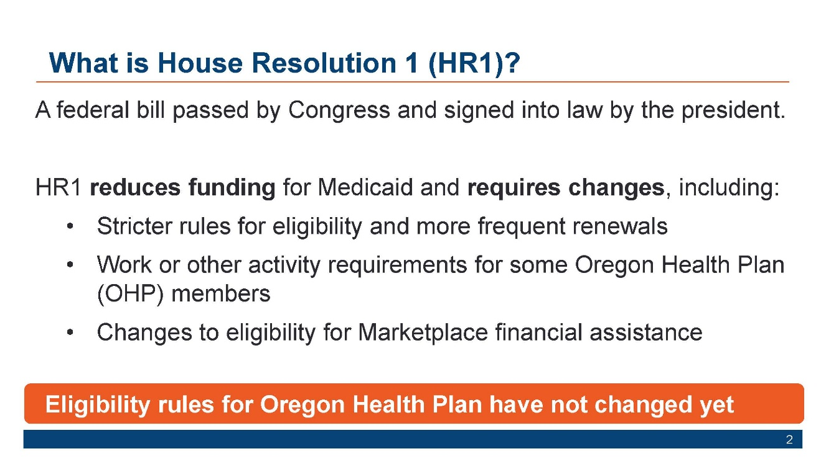
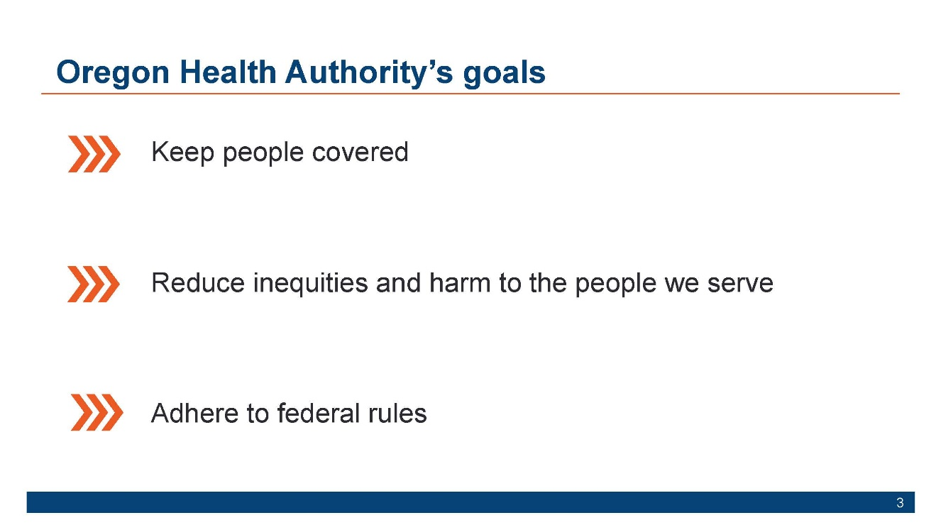
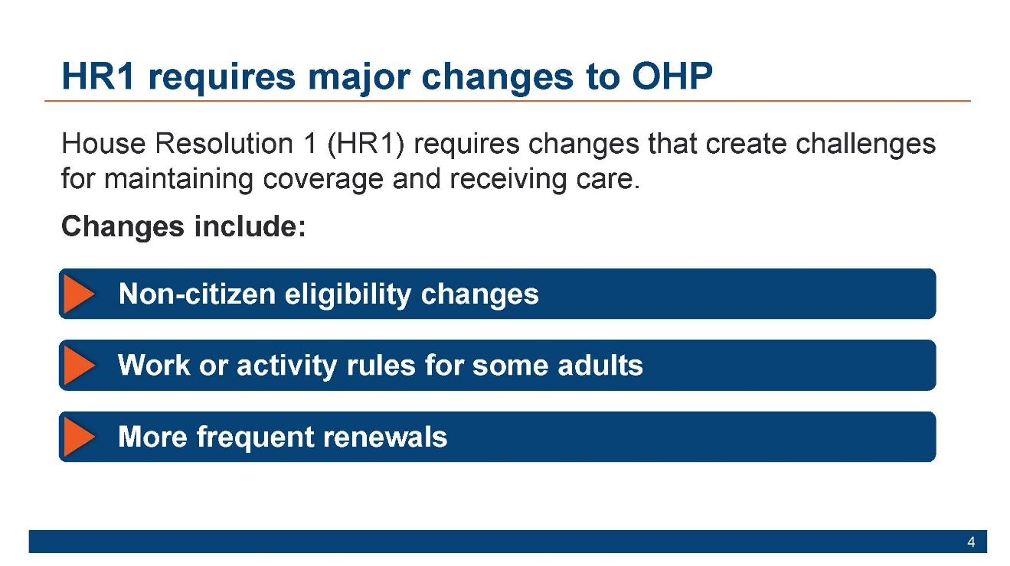
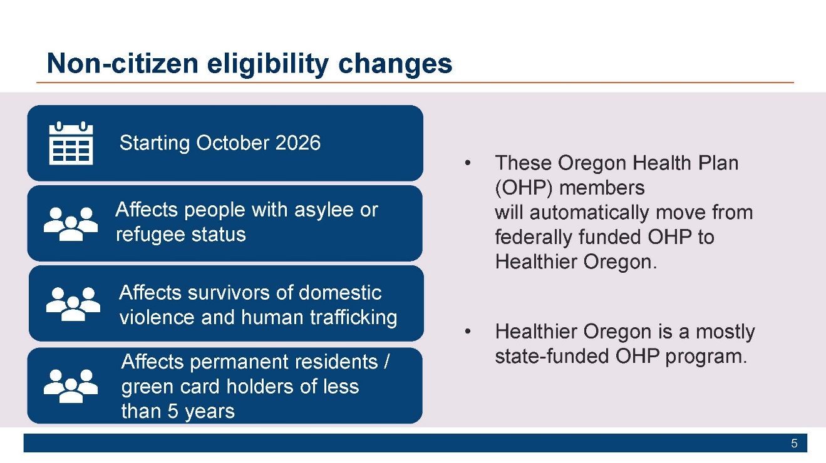
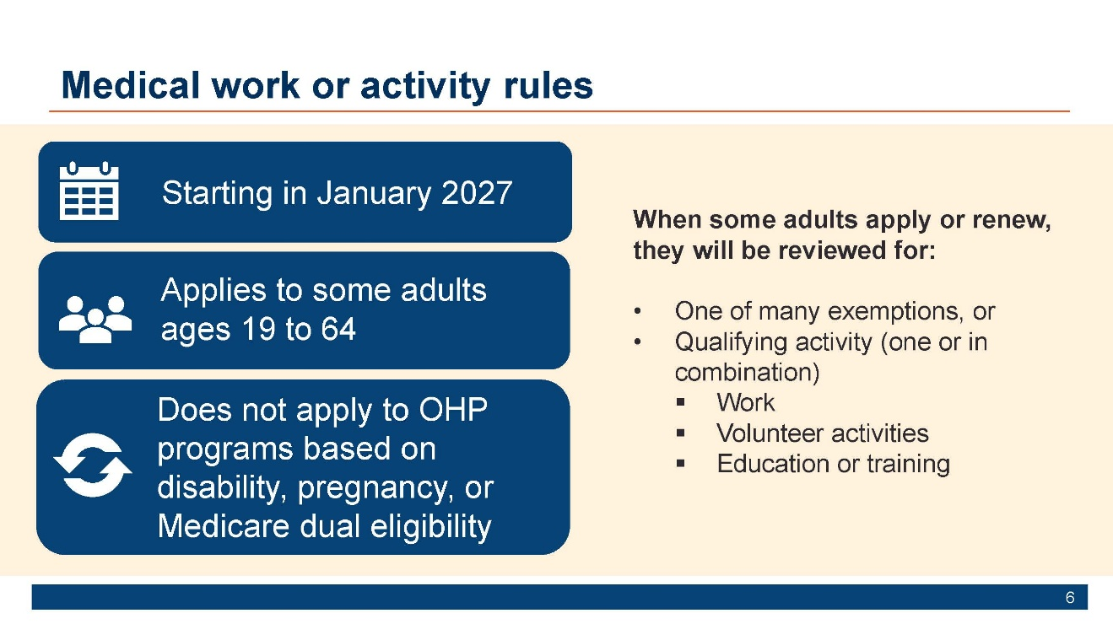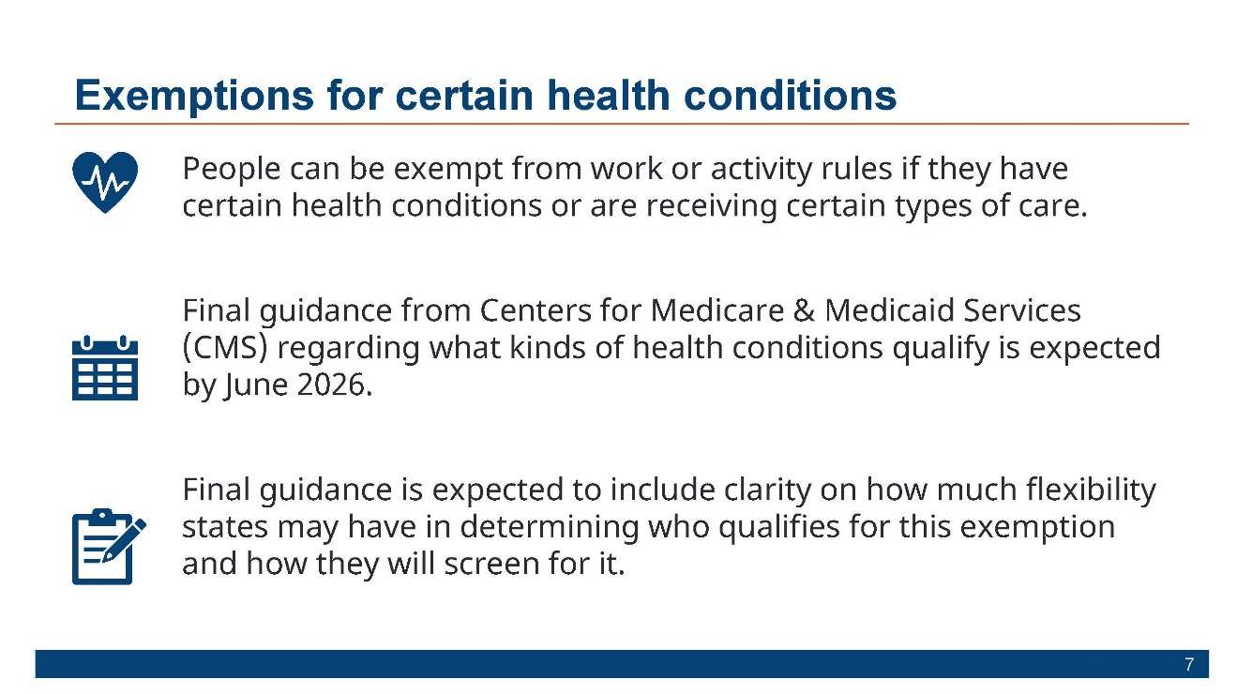
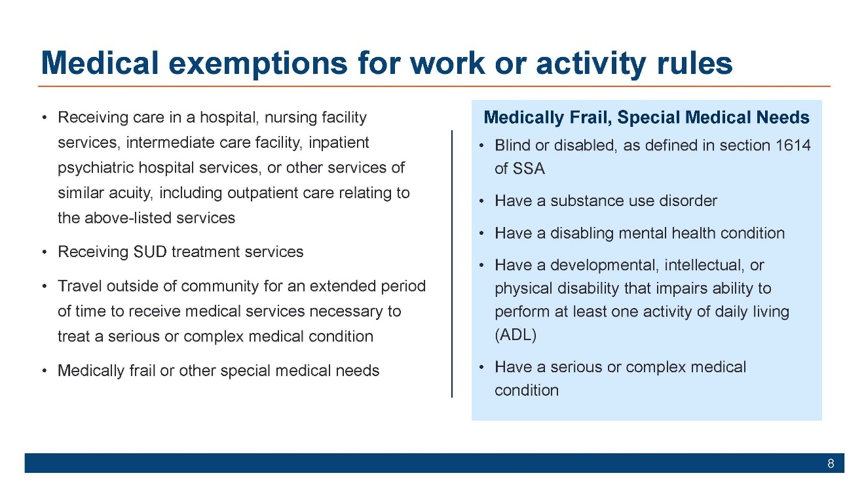
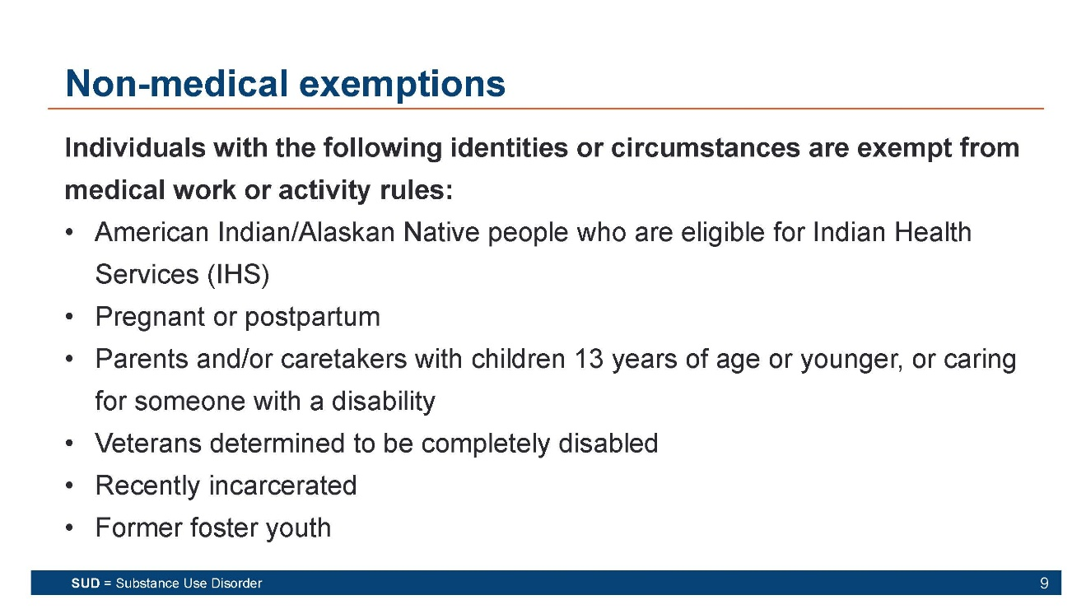
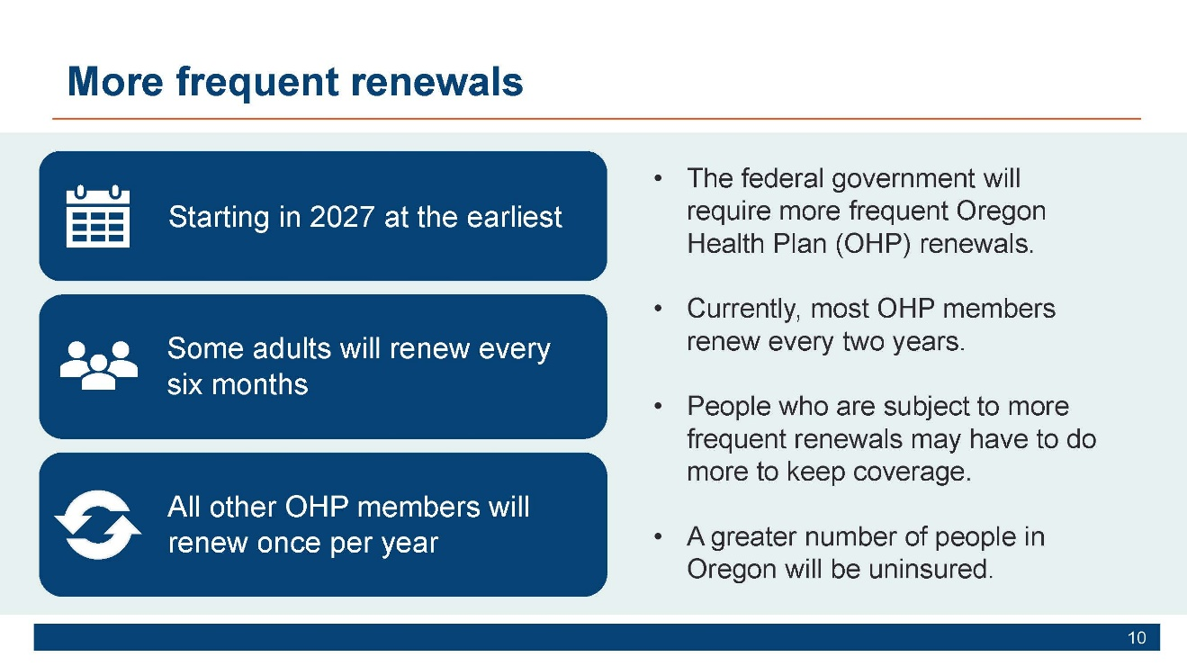
How to stay informed
Web page: Oregon Health Plan Changes Coming Soon
OHP.Oregon.gov/HR1
Newsletter: Oregon Health News
www.oregon.gov/oha/erd/pages/oregon-health-news.aspx
Social Media
  - Instagram: @oregonhealthauthority
  - Facebook (English):facebook.com/OregonHealthAuthority
  - Facebook(Spanish):https://www.facebook.com/OHAespanol/
  - LinkedIn:linkedin.com/company/oregon-health-authority

