Healthy Bytes Initiative Article
November 2019 Brussels Sprouts

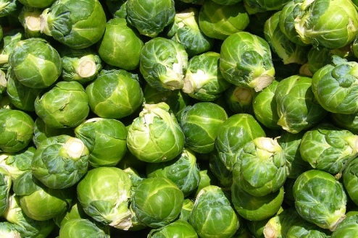
Bring On the Brussels Sprouts!
By Stephanie Polizzi, MPH, RDN

If you’ve never enjoyed roasted Brussels sprouts, now is
the time to discover their sweet, nutty flavor. These
mini-cabbage bundles are packed with disease-fighting
nutrients that fend off heart disease, diabetes and cancer.
They are named after Brussels, Belgium, where it is
believed they were first cultivated, although they were likely grown in Ancient Rome. These buds have the unfortunate reputation for being the “most hated vegetable.” This is likely due to being improperly prepared. Overcooking brings out Sulphur-containing compounds leading to a bitter taste. Prepared correctly, they can be a delicious snack, side dish or salad, enjoyed raw or cooked.

As a member of the cruciferous (cabbage) family, Brussels sprouts contain more cancer-fighting Sulphur compounds than broccoli. They are also higher in vitamin C and beta-carotene vitamin than other cruciferous vegetables. These antioxidants are key to reducing inflammation related to conditions like inflammatory bowel disease, Crohn’s disease, ulcerative colitis, rheumatoid arthritis and type 2 diabetes. They are an excellence source of vitamin K, important for wound-healing, blood clotting and helping absorb calcium into our bones. High in soluble fiber, they can help lower cholesterol and blood sugars.

When shopping for fresh Brussels sprouts, you can often find them still attached to their stalks October through December. They can have 20-40 heads on a stem that can grow up to 3 feet tall. You can find varieties ranging from bright green to purple. Fresh Brussels sprouts should be walnut-sized, tight and firm, with no loose or yellowing leaves. When selecting loose sprouts, choose similar sizes to ensure even cooking. They should last about 10 days in your refrigerator. If freezing, lightly steam 3-5 minutes before placing in cold water. Then drain and package. These will keep up to a year in the freezer.

Roasting is the preferred method of cooking for maximum flavor and nutrition. Wash and remove stems and any discolored leaves. Cut in half for quick cooking. Drizzle sprouts with olive oil and sprinkle seasonings. Spread parchment paper in baking dish and line Brussels sprouts cut side down in a single layer. Bake at 425° for about 20-25 minutes or until soft. Be careful not to overcook since this could bring out a bitter flavor.

You can serve Brussels sprouts raw in salads or slaw, lightly steamed or roasted, pan seared or even as a pizza topping. If using in soups, add last and cook only until tender. Again, if they are overcooked, they will be mushy and bitter. Brussels sprouts are a traditional side dish for Christmas dinner, most likely because they grow well in cooler temperatures. This holiday, surprise your family and guests by preparing Brussels sprouts and celebrate health!

