Healthy Bytes Article
Apr 2019 Mushrooms

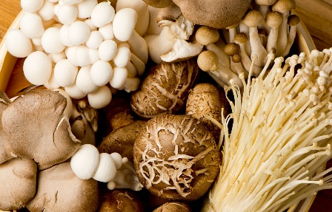
Edible Mushrooms
By Stephanie Polizzi, MPH, RDN

Although we often refer to mushrooms as vegetables, they are not
actually plants at all. They are organisms called fungi (plural for
fungus). With over 140,000 species, we know of about 100 varieties
of edible mushrooms, yet most consumers may only know 3 or 4.

The most common is the cremini, brown buttons with a white stem. Button mushrooms are all white baby versions of cremini, and shiitaki is a full grown, larger version. All have a meaty, nutty flavor that gets richer with age and size. Oyster mushrooms are chewy and spongy, shaped a bit like a squid, often found in Asian markets. Enoki are long, thin, white mushrooms often used in stir-fry dishes and can be used in place of noodles.

Most of the nutrient value is similar across varieties of mushrooms. They are rich in B vitamins which help us get energy from our food, and allow us to form red blood cells. They contain minerals like potassium, copper, iron, phosphorus and selenium (which is a mineral form of antioxidant protective against cancer and inflammation). Depending on where they are grown, they can be a good source of vitamin D, which, along with mushrooms’ calcium and phosphorus content, can help protect bones. High potassium content helps lower blood pressure and reduce risk for heart attack and stroke. Some contain choline, a compound know to help improve sleep, learning and memory.

It is important to note that not all mushrooms are edible, and eating them can result in severe poisoning symptoms including nausea, vomiting, convulsions, coma, even death. Do not eat mushrooms found growing unless you have been trained to identify them as edible. When buying mushrooms, store them in a paper bag or tea towel in the refrigerator and use them within a few days of buying.

Mushrooms can enhance any meal since they are satisfying and loaded with rich flavor. Start by washing well, paying special attention to the gills under the cap, and allow to dry. Mushrooms can be sliced and sautéed, roasted or grilled whole, or used fresh on sandwiches or salads. Cooking brings out the umami flavor, which is considered meaty or savory. This enhances broths and stews, and is especially tasty in vegetarian dishes.

Large portabella mushrooms are often grilled and served on buns with toppings, a healthy replacement for hamburger meat. Portabella mushrooms, sometimes called steaks, are free of cholesterol and saturated fat yet still provide that meaty texture and taste. You can also try coating portabellas with olive oil, rolling in your favorite spices and then baking 20-30 minutes in a 400-degree oven. Serve with mounds of roasted vegetables for a healthy meat-free meal.

