Healthy Bytes Article
Jan 2019 Turnips

Give Turnips a Turn
By Stephanie Polizzi, MPH, RDN
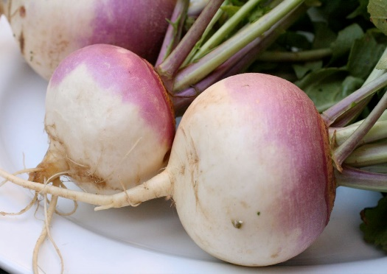
Let’s kick off the New Year by highlighting a much-underused
vegetable great for winter soups and stews, salads and dips.
Turnips look like a root vegetable but are actually members of
the cruciferous or cabbage family. Like its family members
broccoli, cauliflower, Brussels sprouts and kale, it contains
sulforaphane, a compound found to be protective against
cancer. These beauties are also high in fiber and vitamin C
and the greens are a great source of calcium.

One 2-3” turnip has just 34 calories, protein and 4 hefty grams of fiber. Turnips are high in both soluble and insoluble fiber, making them a healthy choice for any diet, but especially for those needing to lower cholesterol or regulate blood sugars. The high fiber also protects against intestinal diseases like diverticulosis and colon cancer. Turnips provide minerals like calcium and potassium, B vitamins and more than half the RDA for vitamin C.

Since turnips have a long shelf-life, they are usually available year-round. When buying turnips, select those firm and free of bruises. The younger, smaller turnips (2-4” in diameter) will have a sweeter flavor than larger ones. The top of the root should be a bright purple fading to a creamy white. If the stems are attached, look for bright greens. Sometimes the stems are removed and sold separately as turnip greens.

You may find larger, yellow varieties in stores. Although similar in color to turnips (purple tops with yellow bottoms), these are actually rutabagas, thought to be a cross between turnips and cabbage. They have similar nutrition content to turnips but in addition, contain beta-carotene, a B-vitamin antioxidant not found in turnips.

Turnip roots can be enjoyed raw or cooked. Simply peel and slice, and add to salads or on veggie trays with hummus or dips. Raw turnips have a zesty, slightly peppery taste. When cooking, remove the greens, wash, trim and peel the root. Dice, grate, chop or slice and cook in soups or stews, or boil until soft and mash into potatoes and/or cauliflower. Roasting is often preferred since it brings out the rich flavor. Turnips can also be sliced thinly and baked into chips for a healthy snack.

Turnip greens are high in vitamins K, A, C and folate. They are rich in beta-carotene and calcium but can be bitter if consumed raw. Most find boiled or steamed greens most appealing but be careful not to overcook, since that can destroy health benefits. Blanching (boil 1 minute then chill in ice water) or quick steaming (less than 5 minutes) is recommended. Adding turnip and other cruciferous greens to your diet can reduce your risk for heart attack and stroke.

