Healthy Bytes Article
Jun 2018 Cauliflower

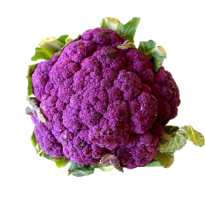
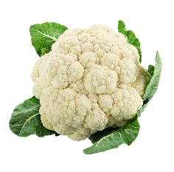
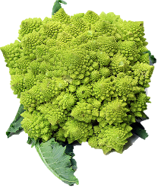
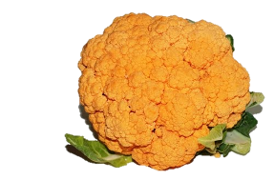
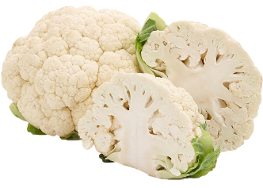
Amazing Cauliflower
By Stephanie Polizzi, MPH, RDN

A kissing cousin of broccoli, cauliflower is another member
of the cabbage family, and as such, also has compounds
that fight cancer and other diseases. It ranks among the top
20 foods for its nutrient content, low calories and high fiber.

Cauliflower is rich in protective nutrients like vitamin K and omega 3 fats that help to lower inflammation. Just one cup of raw cauliflower has 77% of our recommended daily intake for vitamin C which lowers inflammation, boosts our immune function and aids in the absorption of iron. Cauliflower is also a good source of carotenoids, flavonoids, and other antioxidants that protect us from developing heart disease and stroke. Plant sterols, known as phytosterols, help lower cholesterol and reduce plaque build-up in the arteries. Potassium regulates fluid balance and can lower blood pressure.

Along with B vitamins like B6 and folate, this vegetable is also a good source of choline, an essential nutrient that can be difficult to obtain from our food. Choline helps with brain development and nerve transmission and also helps lower cholesterol. Vitamin K helps with blood clotting and protects our bones from osteoporosis.

Not only can cauliflower help to prevent heart disease and stroke, but studies show that regular intake of this and other cruciferous vegetables can kill tumor cells and prevent cancer from forming or growing. It has been shown to be particularly helpful in preventing breast cancer but regular intake is also associated with lower risk of lung, prostate, ovarian, cervical and gastrointestinal cancers.

Most people know cauliflower as a large, white head which averages 5-6 inches in diameter. There are also varieties in green, orange and purple. The Broccoflower is the color of broccoli and has a sweet taste. Orange cauliflower has higher levels of the antioxidant, beta carotene. The purple variety, sometimes referred to as Sicilian Violet, is purple on the outside but white inside. The color is due to anthocyanin, a power antioxidant. These varieties retain their colors after cooking which help to create a bright, colorful and appetizing plate.

But be careful not to overcook since cooking can destroy many of the vitamins. Cooking 30 minutes can reduce the health benefits of cauliflower by 75%.

Cauliflower can be used in a variety of ways. Chop raw for finger foods with dips, salad topping or as a sandwich side item in lunch boxes. Steam, roast or saute as a side dish. Throw into soups, stews, casserole or stir fry. Mash into potatoes or mac and cheese, or flavor with spices and use as a sandwich spread.

